PAPER TITLE
First Author Name, Second Author Name, Third Author Name
University, Street, Town, Country
first_author@xyz.com, second_author@.xyz.com, third_author@xyz.net
Abstract: Please consider these Instructions as guidelines for preparation of Final Camera-Ready Papers. Type the abstract using Italic font with point size 10, Times New Roman) Use short, direct, and complete sentences. It should be as brief as possible and concise. It should be complete, self-explanatory, and not require reference to the paper itself.
Keywords: A Maximum of 6 Keywords separated by semicolon (;)
Important: The title, authors, abstract and keywords should be identical with the abstract proposal made on conference website.
- CHAPTER I/ FRAMEWORK
The paper must have an even number of pages, font Times New Roman 12, not numbered and written in English. Italic characters must be used to underline. In the final note of the paper, the identification dates of the author (authors) must be mentioned. The abbreviations may be used only if they have been explained during their first mentioning in the text. The (superior/inferior) indicators and the mathematical symbols have to be easily identified. Do not add any text to the headers (do not set running heads) and footers, not even page numbers, because text will be added electronically. The references will be mentioned at the end of the paper, and [ ] will be used. The equations, charts and figures will be introduced in the text and will be edited according to the examples presented here.

  - Sub-chapter I
Here starts the first sub-chapter. ….
- CHAPTER II
Beginning of chapter II. Sub-chapters may be added, whenever the case. At the end of this chapter ENTER should be clicked on and COPY PASTE should be used to add a new chapter if necessary.

- First sub-chapter of the second chapter
Here starts the first sub-chapter of the second chapter... The examples that follow present models for equations, charts and figures. The equations should be numbered with Arabic numbers in round parenthesis place on the right side (the example given should be copied and modified if necessary). Figure resolution should be at least 300 dpi.. The chart may be similar to our example.

$\frac{dω}{\text{dt}}=ε\text{ , }m_{2}\text{cos}φ=F_{z}\text{.}$ (1)
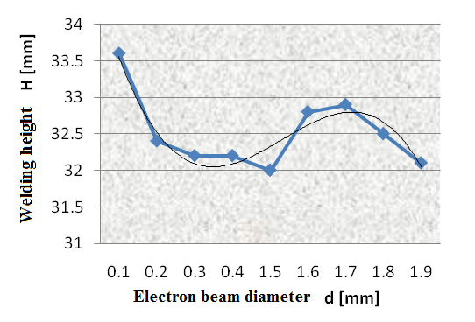
Fig.1. Figure name
 | Column Title | Column Title 2 | Column Title3
 | Row1
 | Row2
 | Row3
Table xy. Chart name
- CONCLUSIONS
Conclusions of your study.
Acknowledgements
If any, should be placed before the references section without numbering.
Reference Text and Citations
References should be set to 10-point, justified.

- Constantin I., Popescu, A., 2011. Paper title. In INVENTICA 2011, 15st International Conference of Inventics. Tehno Press. Pag 22
- Popescu A., 2005. The book, The publishing company. Iasi, 5th edition. Page 29

